January 2021


Transform Your RE with Belonging and Believing
This wonderful new series explores the lived experience of a five-year old child, their family and community.
The series reflects 8 different religions and worldviews.


Resource | Qty | Price | Total
Belonging and Believing: (Hardback books)
My Bahá’í Family |  | £14.99
My Buddhist Family |  | £14.99
My Christian Family |  | £14.99
My Hindu Family |  | £14.99
My Humanist Family |  | £14.99
My Jewish Family |  | £14.99
My Muslim Family |  | £14.99
My Sikh Family |  | £14.99
Full set offer: All 8 books as above (save £9.92). P&P at £8.50 (for up to 4 sets – the most economical P&P will be applied to greater quantities) |  | £110
www.booksatpress.co.uk

7 Butlers Mead, Millend,
Blakeney, GL15 4EH

Phone/Fax (01594)516 490
orders@booksatpress.co.uk
www.booksatpress.co.uk

We give you five easy ways to order:

- Online via our website
- Fill out the order form and
- Fax it
- Post it
- Email it
- Call us

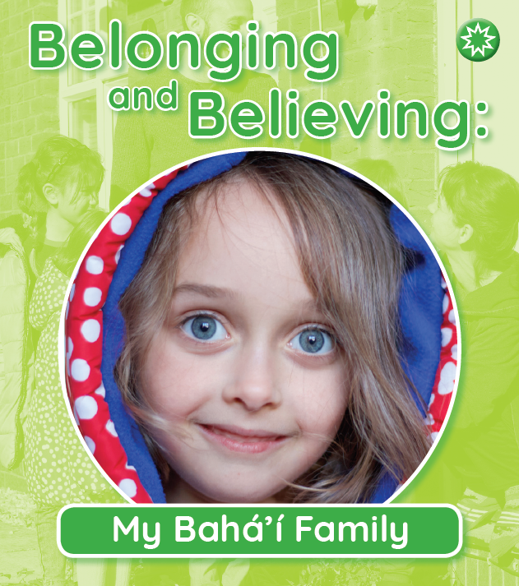
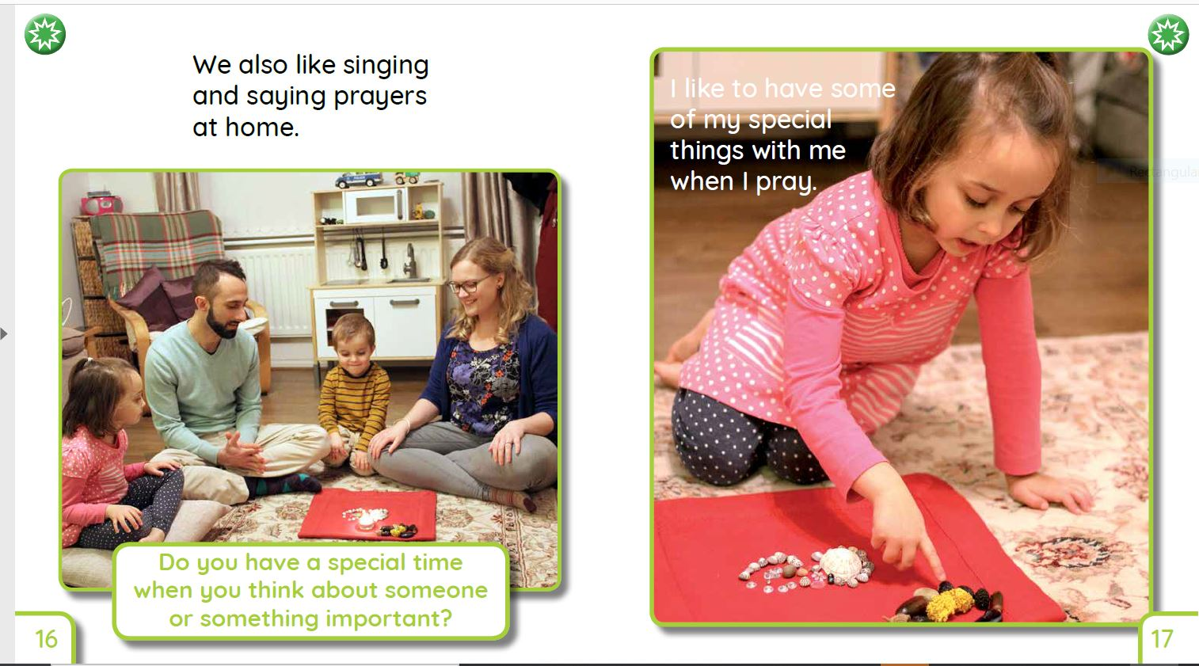

School / Organisation: ……………………………….……………………………….
Order No……………….…………………………………………………….………………
Name: …………………………………………………………………………………..…….
Position: ……………………………………………………………………………………..
Phone:………………….……………………………………………………….…………….
Address:………………………………………………………………………………………
………………………………………………..………………………..………………………..
………………………………………………..………………………..………………………..
Post Code:…………………………………………………………………………………..
Email:……………………………………………………………………………………………
Please invoice us for payment when books are despatched.

Where did you hear about the resources?
........……………………………………………………………………………………………
………………………………………………………………………………….………………..

